**ASSIGNMENT 24.5**

**Problem Statement**

**Input File-**

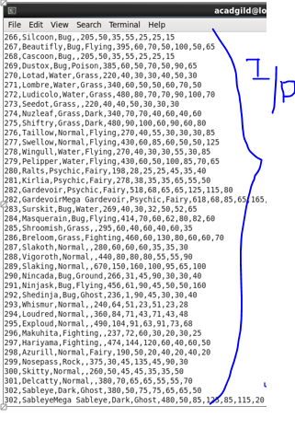

**Find out the average HP (Hit points) of all the Pokémons**

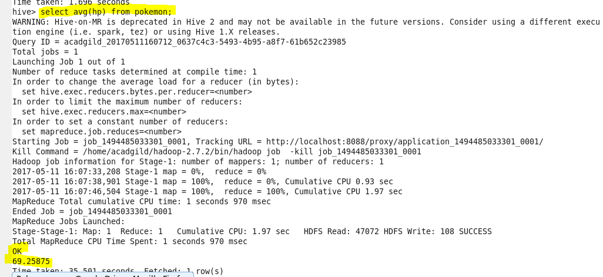

**Find out the average Defense of all the pokemon**

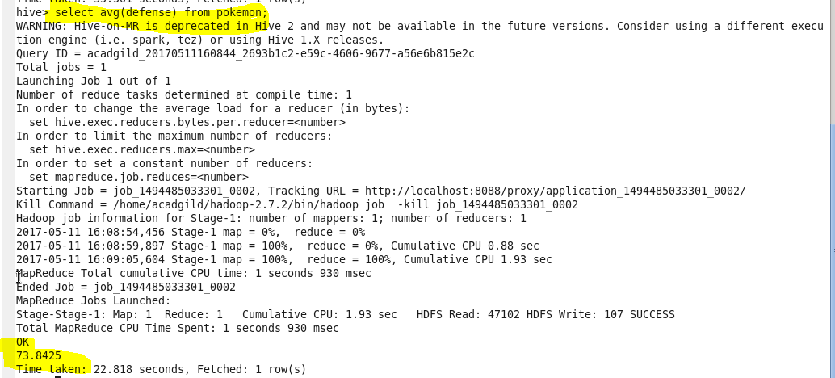

**Find out the average Sp.Atk of all the pokemons**

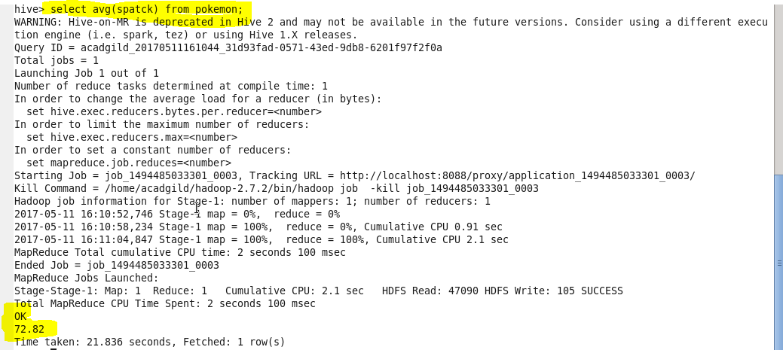

**Find out the average sp.Def of all the pokemons**

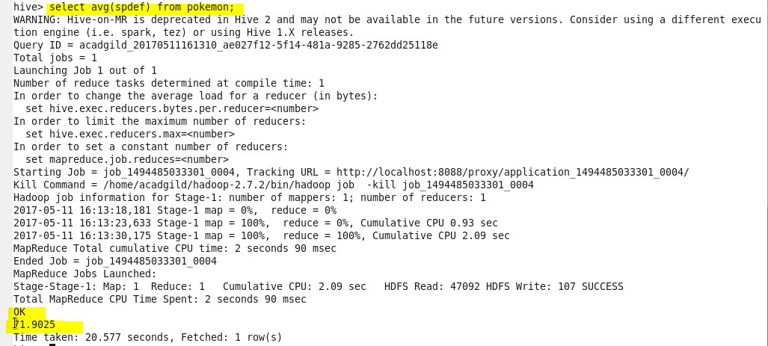

**Find out the average Speed of all the pokemons**

